

YEAR: 9
SUBJECT: SCIENCE

TEST: Heat and Electricity
TIME: 40 minutes
QUESTIONS: 10 Multiple Choice (10 marks)
6 Short Answer (20 marks)

TOTAL MARKS: 30 marks

DO NOT WRITE ON OR MARK THIS PAPER
SECTION ONE – MULTIPLE CHOICE (10 marks)
This section has 10 questions. Answer all questions on the separate multiple-choice answer sheet provided.

1. On a hot summer’s day a cool sea breeze is blown from the ocean to the shore. This is an example of
a. conduction
b. convection
c. radiation
d. insulation

2. The current that flows in the circuit is?
a. electron
b. proton
c. neutron
d. ion

3. Which of the following materials is an insulator?
a. copper
b. nichrome
c. rubber
d. aluminium

4. The unit used to measure electric current is:
a. amperes
b. volts
c. ohms
d. ammeter

5. The instrument used to measure voltage is called:
a. an ammeter
b. a battery
c. a voltmeter
d. a switch

6. Two light globes are attached in parallel with a battery. If another light globe is attached in parallel. What would happen to the brightness of the first two globes? They
a. get duller.
b. get brighter.
c. stay the same brightness.
d. would all ‘blow’.
7. In a torch light, the voltage comes from
a. the light bulb
b. the switch
c. the battery
d. the handle

8. What colour would the Earth wire be for household wiring
a. red
b. brown
c. blue
d. green and yellow

9. To protect people from getting shocked, wires should be covered by
a. insulators
b. conductors
c. metals
d. Aluminium

10. How does a switch turn off an appliance?
a. Stopping the voltage
b. Increasing the resistance
c. Cutting off the current
d. Creating a close circuit

ANSWER BOOKLET

NAME:

FORM: DATE:

Multiple Choice Short Answer Total

/10
/20

/30

/20
/25

SECTION ONE: Multiple choice answers
Cross (X) through the correct answer.
1 | a | b | c | d
2 | a | b | c | d
3 | a | b | c | d
4 | a | b | c | d
5 | a | b | c | d
6 | a | b | c | d
7 | a | b | c | d
8 | a | b | c | d
9 | a | b | c | d
10 | a | b | c | d

SECTION TWO: Short Answer (20 marks)
1. List two advantages that parallel circuits have over series circuits. (2 marks)

________________________________________________________________________________
________________________________________________________________________________
________________________________________________________________________________
________________________________________________________________________________
2. Recall the following terms by matching each term (a to c) with its correct description ( i to iii).
(3 marks)
a) current | i) measures how difficult it is for charges to pass through a material
b) voltage | ii) measures the flow of charge passing through the circuit
c) resistance | iii) measures the energy provided to or used by charges

3. Look at the diagram below.
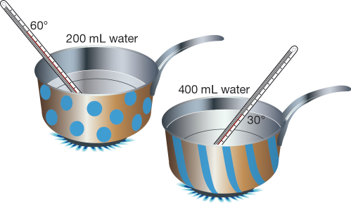
a) Explain why the base of each saucepan is metal, but the handles are made from a tough plastic. (2 marks)
________________________________________________________________________________
________________________________________________________________________________
________________________________________________________________________________
b) Why does the water in the spotty saucepan heat up faster? (1 mark)
________________________________________________________________________________
________________________________________________________________________________
4. A torch light is made up of
- 2 cells
- Switch
- Light bulb
- Draw a LABELLED circuit diagram below (4 marks)
- If each of the cells is 1.5V, what is the total voltage needed to power the torch light? ( 1 mark)
____________________________
5. Below draw a circuit diagram of the following (4 marks)
- Voltage source / battery
- 3 light bulbs in parallel
- Switch to turn on and off ALL the lights
- Ammeter measuring the current for 1 light bulb

6. In the house, there are some measures taken when there is an overload in the household appliances.
a) Explain how fuses OR circuit breakers work in that situation. (2 marks)
________________________________________________________________________
________________________________________________________________________
________________________________________________________________________
b) What are 2 disadvantages for fuses compared to circuit breakers (1 mark)
________________________________________________________________________
________________________________________________________________________

